**ToyCraft Tales: Tableau's Vision into Toy Manufacturer Data**

In the toy industry—where demand can be seasonal and quality is critical—Tableau enables

quick and clear analysis of every stage in the manufacturing process. From factory output to

market feedback, Tableau helps ensure toys are made efficiently and reach the right

customers at the right time.

1. 📊Real-Time Data Visualization

Instantly see production status, sales performance, and inventory levels through dynamic

dashboards.

2. 🔍Better Decision-Making

Helps managers identify issues quickly (e.g., defects, delays) and act based on data, not

guesswork.

3. 🚚Improved Supply Chain Efficiency

Tracks supplier performance, lead times, and raw material availability to avoid production

bottlenecks.

4. 🎯Sales & Demand Forecasting

Analyzes seasonal trends and customer preferences to plan production and marketing

effectively.

5. ⚙Quality Control Monitoring

Visualizes defect rates, product testing results, and compliance metrics to maintain high

standards.

6. 💼Cross-Department Collaboration

Teams in production, sales, and logistics can access the same dashboards for unified

decision-making.

7. 📱Mobile Accessibility

Dashboards can be viewed on tablets and phones, allowing on-the-go insights for managers.

8. 🧠 Tableau can integrate with machine learning tools to predict demand and maintenance need

Tableau toy craft refers to a project showcasing eco-friendly wooden toys from Andhra

Pradesh's Etikoppaka village. The craft, known as Etikoppaka Bommalu, features vibrant,

intricately designed toys made from natural materials like wood from the Ankudu tree and

non-toxic dyes derived from plants.

1.Eco-friendly: Made from natural materials, ensuring sustainability and non-toxicity

Traditional Craftsmanship: Utilizes a 400-year-old lacquer-turning technique for a lustrous

finish

●Cultural Significance: Depicts mythological characters, animals, and musical instruments,

reflecting India's rich cultural heritage

●Unique Designs: Inspired by nature, with motifs like flowers, animals, and geometric

patterns

●Recognition and Significance:

●Geographical Indication (GI) Tag: Received in 2017, ensuring authenticity and preserving

cultural significance

●International Recognition: Admired by collectors and eco-conscious enthusiasts worldwide

●Promotion: Featured in Andhra Pradesh's tableau during India's Republic Day celebrations,

promoting eco-friendly crafts and local industries ¹ ²

Tableau empowers toy manufacturers to make smarter, faster decisions by turning complex

data into clear, actionable insights. From tracking production and quality to forecasting

demand and managing inventory, Tableau helps improve efficiency, reduce costs, and

deliver better products to market. By using data visually and effectively, toy companies can

stay competitive and responsive in a fast-changing industry.

Toycraft, in this context, likely refers to the Etikoppaka wooden toys from Andhra Pradesh,

India, which were featured in a tableau at the Republic Day parade. The tableau showcased

the traditional craft of making these toys, which are known for their vibrant colors and

intricate designs. The related story is about the cultural significance of these toys and the

artisans who create them, highlighting their role in preserving Andhra Pradesh's heritage.

Here's a more detailed explanation:

Etikoppaka Toys:

These are handcrafted wooden toys made in the village of Etikoppaka, located near

Visakhapatnam.

Toycraft Tableau:

The tableau at the Republic Day parade was a visual representation of the Etikoppaka

toy-making tradition, featuring Lord Venkateswara and other elements like Haridasu and

Bommala Koluvu.

Cultural Significance:

The toys are a living testament to Andhra Pradesh's cultural heritage, known for their vibrant

colors derived from natural dyes and their intricate designs that harken back to ancient

civilizations.

Artisans' Role:

Many families in Etikoppaka have been making these toys for generations, using techniques

passed down through families. The toys are crafted from Ankudu tree wood and colored with

natural dyes.

Republic Day Feature:

The tableau's participation in the Republic Day parade brought national and international

recognition to the craft and its artisans.

GI Tag:

The Etikoppaka toys were also recognized with a Geographical Indication (GI) tag in 2017,

further solidifying their authenticity and cultural significance.

The term "Toy Village" refers to places known for traditional toy-making, particularly wooden

toys. Channapatna in Karnataka and Kondapalli in Andhra Pradesh are famous examples of

such villages. These villages have a rich history of crafting toys using indigenous techniques

and materials, often involving lacquering and wood carving.

Traditional Toy Making:

The process of crafting toys, including wood selection, shaping, lacquering, and painting.

Artisans and Craftsmanship:

The skills and knowledge passed down through generations, often involving family-based

workshops.

Materials and Techniques:

The use of local wood (like Wrightia tinctoria in Channapatna), natural dyes, and lacquering

techniques.

Cultural Significance:

The role of toys in storytelling, religious traditions, and local customs.

Economic Importance:

The contribution of toy-making to local livelihoods and the economy.

Challenges and Threats:

The impact of mass-produced plastic toys, economic pressures, and the need for preservation and support.

Preservation Efforts:

Initiatives to promote and protect traditional toy-making, including GI (Geographical

Indication) tags and support for artisans.

Modern Interpretations:

How traditional crafts are being adapted to contemporary designs and markets.

Tourism and Souvenirs:

The role of toy villages as tourist destinations and sources of unique handicrafts.

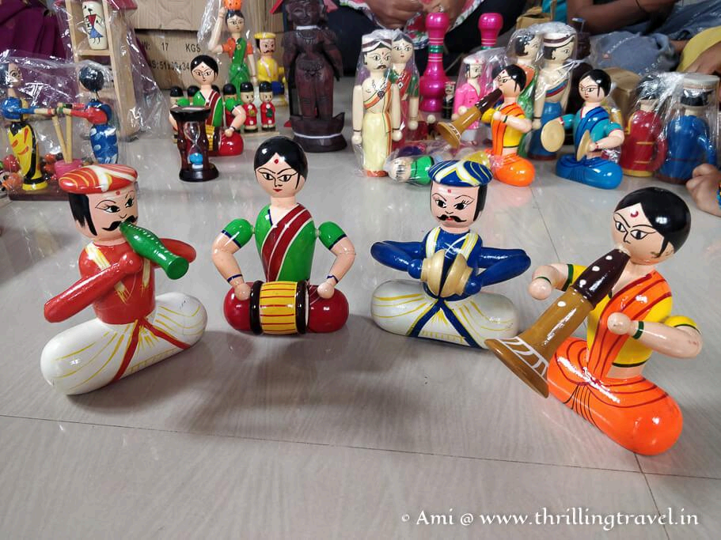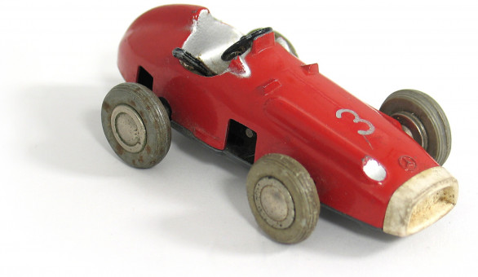

Pie charts are used to visually represent data as slices of a circle, where each slice's size

corresponds to its proportion of the whole. In the context of piecraft manufacturing, pie

charts could be used to display various aspects of the business, such as the percentage of

revenue from different products, the distribution of manufacturing costs, or the proportion of

different materials used.

Here's how pie charts could be applied in piecraft manufacturing:

1. Product Sales Distribution: A pie chart could show the percentage of total revenue

generated by each type of pie (e.g., apple pie, cherry pie, pecan pie). This helps identify

which pies are the most popular and profitable.

2. Cost Breakdown: A pie chart can illustrate the proportion of total manufacturing costs

attributed to different categories, such as ingredients, labor, packaging, and utilities. This

helps pinpoint areas where cost reduction efforts may be most effective.

3. Material Usage: A pie chart can visualize the percentage of different ingredients or

materials used in pie production (e.g., flour, sugar, butter, fruit). This can be useful for

inventory management and sourcing decisions.

4. Production Efficiency: A pie chart could show the percentage of time spent on different

production activities (e.g., mixing, baking, cooling, packaging). This can help identify

bottlenecks and improve overall production efficiency.

5. Sales by Region: A pie chart can display the distribution of pie sales across different

geographic locations, helping to understand regional demand patterns.

6. Ingredient Sourcing: A pie chart could illustrate the percentage of ingredients sourced

from different suppliers. This is useful for ensuring supply chain diversity and managing

potential risks.

Steps to Create a Pie Chart:

1. Gather Data:Collect the relevant data for the aspect of the business you want to visualize (e.g., sales

figures, cost breakdowns, material quantities).

2. Calculate Percentages:Determine the percentage of each category by dividing its value by the total value and

multiplying by 100.

3. Calculate Degrees:Convert percentages into degrees by multiplying each percentage by 360 (since a circle has 360 degrees).

4. Draw the Circle: Use a compass to draw a circle.

5. Divide into Sectors: Use a protractor to divide the circle into sectors based on the calculated degrees.

6. Label and Color: Label each sector with its category and corresponding percentage, and assign a distinct color to each sector for clarity.

Example:

Let's say a piecraft company sells three types of pies: Apple, Cherry, and Blueberry. The

total sales for a month are $13,000. Apple Pie sales: $5,000 (50%), Cherry Pie sales: $3,000

(30%), and Blueberry Pie sales: $4,000 (40%).

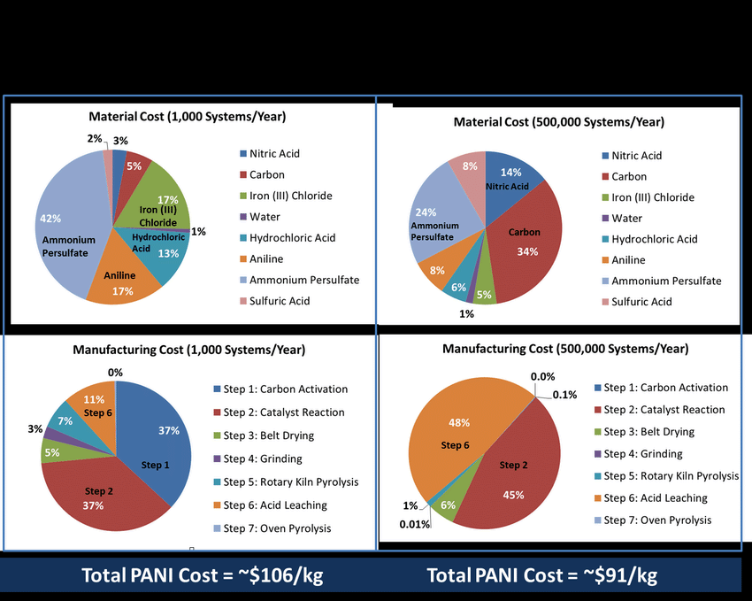

Performance testing of toy crafts involves evaluating the durability, functionality, and safety of the toys to ensure they meet established standards and are suitable for their intended use. This includes assessing aspects like strength, impact resistance, and potential hazards like sharp edges or small parts.Here's a breakdown of common performance tests for toys:1. Mechanical/Physical Testing:

Impact Testing:Simulates drops and impacts to assess the toy's ability to withstand falls and prevent breakage, sharp edges, or loose parts.

Drop/Impact Testing:

Evaluates the durability and safety of toys by simulating drops from a specific height onto

various surfaces.

Compression Testing:

Assesses the toy's resistance to being crushed or deformed under pressure.

Torque Testing:

Measures the resistance of the toy's components to twisting or rotational forces, ensuring

they don't easily break or detach.

Tensile Testing:

Evaluates the strength of the toy's materials and connections by pulling them apart.

1.Fatigue Testing: Determines how well the toy withstands repeated stress and strain over time.

Sharp Point and Edge Testing:

Checks for sharp points or edges on the toy that could injure a child.

Small Parts Testing:

Ensures that small parts on the toy cannot be easily detached and pose a choking hazard.

2. Safety Testing:Flammability Testing: Assesses the toy's flammability and burning rate to minimize fire

hazards.

Chemical Testing: Checks for the presence of harmful chemicals like lead and other heavy

metals in the toy's materials.

Toxicity Testing: Ensures that the materials used in the toy are non-toxic and safe for

children.

3. Functional Testing:Functionality Assessment: Verifies that the toy performs as intended and that all its features

work correctly.

Ease of Use: Evaluates how easily a child can operate and interact with the toy.

Engagement: Assesses the toy's appeal and ability to hold a child's attention.

4. Other Considerations:

Packaging and Labeling: Ensuring packaging is clear, accurate, and meets legal

requirements.

Age Appropriateness: Confirming the toy is suitable for the intended age group.

Durability and Reliability: Assessing the toy's ability to withstand normal use and play.

By conducting these tests, toy manufacturers can identify potential safety issues, improve

product quality, and ensure that toys are fun, engaging, and safe for children

**Counting and Sorting:**

Toys like blocks, beads, or even everyday objects can be used to create simple graphs,

allowing children to count and sort items based on different criteria.

Early Number Sense:

Creating graphs with toys can introduce concepts like quantity, comparison (more/less), and

basic addition and subtraction.

Data Representation:

Children can learn to represent data visually, understanding how to use symbols or pictures

to show quantities and relationships.

Enhancing Cognitive and Motor Skills:

Focus and Concentration:

Working with toys to create graphs can improve a child's ability to focus and concentrate on

a task.

Fine Motor Skills:Drawing, manipulating small objects, and placing them on a graph helps develop fine motor

skills.

Spatial Awareness: Understanding the relationship between objects on a graph and their position in space can

enhance spatial reasoning.Making Learning Fun and Engaging:

Playful Learning: Using toys to learn about graphs makes the process more enjoyable and less intimidating for

young children.

Active Engagement: Toy-based activities encourage children to be actively involved in the learning process, rather than passively receiving information.

Real-World Connections: Graphing with toys can help children see how math is used in everyday situations, making it

more relevant and meaningful.

Examples of Toy-Based Graph Activities:

Sorting toys by color: Children can sort blocks, beads, or toy cars by color and then create a bar graph to show

how many of each color they have.

Creating a picture graph: Children can use stickers or drawings to represent different types of food, animals, or objects, creating a picture graph to display their collection.

Using building blocks to represent data:

Children can use blocks to create towers of different heights to represent the number of

books read, the number of siblings, or other data points.

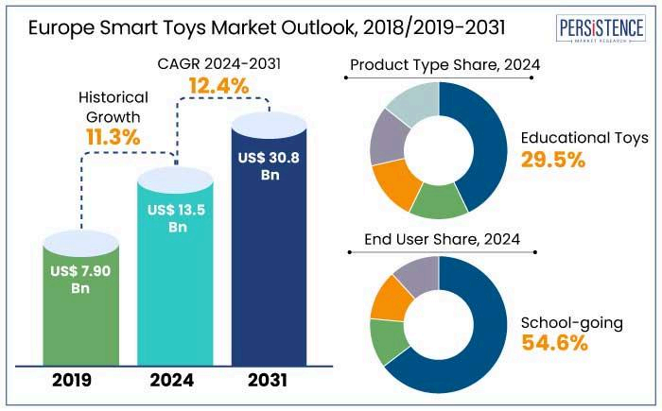

In toy craft manufacturing, calculation fields are used for various purposes, including cost

analysis, production tracking, and quality control. These fields help in determining the cost of

materials, labor, and overhead, as well as tracking production efficiency and identifying

defective items.Here's a breakdown of common calculation fields:

1. Cost Calculation:

Raw Material Costs:

Calculating the cost of wood, plastic, fabric, or other materials used in production. This

involves considering factors like material type, quantity, and supplier costs.

Direct Labor Costs:

Calculating the cost of labor directly involved in the manufacturing process, including wages

and benefits for machine operators, assemblers, and other production staff.

Indirect Labor Costs:

Calculating the cost of labor not directly involved in production, such as supervisors, quality

control personnel, and maintenance staff.

Overhead Costs:

Calculating the cost of indirect expenses like rent, utilities, equipment maintenance, and

depreciation.

Total Production Cost:

Summing up all direct and indirect costs to determine the total cost of producing a batch of

toys.

Cost per Toy:

Dividing the total production cost by the number of toys produced to determine the cost of

each individual toy.

Selling Price Calculation:

Using cost information to determine the selling price of toys, potentially adding a profit

margin.

2. Production Tracking:

Units Produced:

Tracking the number of toys completed per production run or per machine.

Production Time:

Measuring the time taken to complete each stage of production, identifying bottlenecks and

optimizing workflow.

Defet rate

Calculating the percentage of defective toys produced, which helps in identifying areas for

quality improvement.

Efficiency Rate:

Measuring the efficiency of production lines and individual workers based on output and

time.

3. Quality Control:

Defect Rate:

Calculating the percentage of defective toys produced, which helps in identifying areas for

quality improvement.

Pass/Fail Criteria:

Establishing criteria for acceptable quality and tracking the number of toys that meet these

standards.

4. Other Calculations:

Material Usage: Tracking the amount of raw materials used per toy or per production run.

Waste Calculation: Measuring the amount of scrap or waste generated during production,

which can be used to optimize material usage and reduce waste.

Machine Utilization: Tracking the amount of time machines are in operation, identifying

potential underutilization or downtime.

Examples:

KVIC (Khadi and Village Industries Commission)

provides project profiles for toy manufacturing, including cost calculations for raw materials,

labor, and other expenses.

123FormBuilder

offers templates for toy manufacturing calculation forms, which can be used to track various

cost and production metrics.

By utilizing these calculation fields, toy craft manufacturers can gain valuable insights into

their operations, optimize their processes, and improve their overall profitability.

To create a dashboard and story embed with UI using Flask for ToyCraft manufacturing,

you'll need to integrate Tableau's APIs and tools. Here's a high-level overview:

*Requirements*

- *Tableau Server or Online*: Host your dashboards and stories.

*Tableau APIs*: Use REST API or JavaScript API to embed dashboards and stories.

- *Flask*: Build a web application to integrate with Tableau.

*Steps*

1. *Create Dashboards and Stories*: Design and publish dashboards and stories in Tableau.

2. *Get Dashboard and Story URLs*: Retrieve the URLs for embedding.

3. *Use Tableau JavaScript API*: Embed dashboards and stories in your Flask web

application using the JavaScript API.

4. *Customize UI*: Design a user-friendly interface for your application.

*Example Code (Flask and Tableau JavaScript API)*

```

from flask import Flask, render_template

app = Flask(__name__)

@app.route("/")

def index():

return render_template("index.html")

if __name__ == "__main__":

app.run(debug=True)

```

```

<!-- index.html -->

<!DOCTYPE html>

<html>

<head>

<title>ToyCraft Manufacturing Dashboard</title>

<script src="https://public.tableau.com/javascripts/api/tableau-2.min.js"></script>

</head>

<body>

<div id="tableauViz" style="width: 800px; height: 600px;"></div>

<script>

function initViz() {

var viz = new tableau.Viz(

document.getElementById("tableauViz"),

"https://your-tableau-server.com/views/ToyCraftManufacturing/Dashboard"

);

}

initViz();

</script>

</body>

</html>

```

*Benefits*

*Real-time Insights*: Embed dashboards and stories for real-time data visualization.

- *Customizable UI*: Design a tailored interface for your application.

- *Seamless Integration*: Use Tableau's APIs for a smooth integration experience.

By following these steps and using the example code, you can create a powerful dashboard

and story embed with UI for ToyCraft manufacturing using Flask and Tableau.

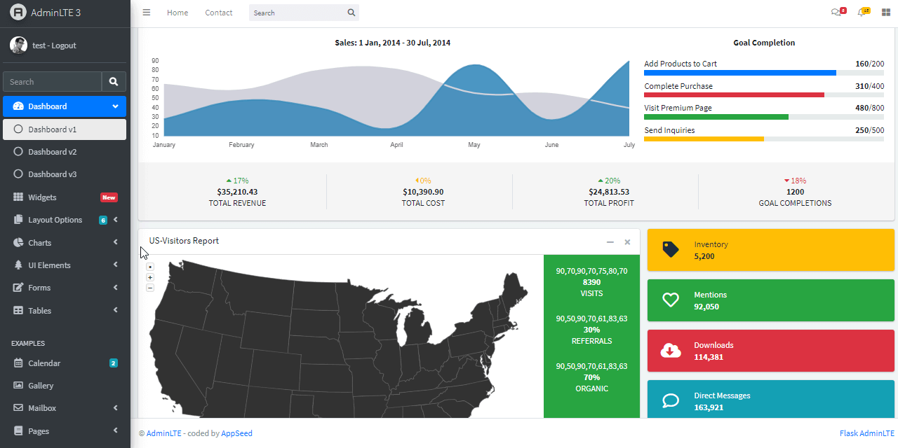

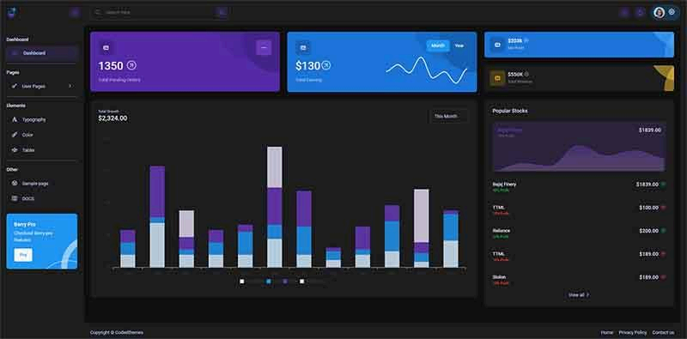

Clean Data from Excel, CSV, PDF, and Google Sheets with Data Interpreter

*Applies to: Tableau Cloud, Tableau Desktop, Tableau Server*

When you track data in Excel spreadsheets, you create them with the human interface in mind. To make your spreadsheets easy to read, you might include things like titles, stacked headers, notes, maybe empty rows and columns to add white space, and you probably have multiple tabs of data too.

When you want to analyze this data in Tableau, these aesthetically pleasing attributes make it very difficult for Tableau to interpret your data. That’s where Data Interpreter can help.

**Tip:** Though Tableau's Excel add-in is no longer supported, Data Interpreter can help you reshape your data for analysis in Tableau.

What does Data Interpreter do?

Data Interpreter can give you a head start when cleaning your data. It can detect things like titles, notes, footers, empty cells, and so on and bypass them to identify the actual fields and values in your data set.

It can even detect additional tables and sub-tables so that you can work with a subset of your data independently of the other data.

After Data Interpreter has done its magic, you can check its work to make sure it captured the data that you wanted and identified it correctly. Then, you can make any necessary adjustments.

After you select the data that you want to work with, you might also need to do some additional cleaning steps like pivoting your data, splitting fields, or adding filters to get the data in the shape you want before starting your analysis.

**Note**: If your data needs more cleaning than what Data Interpreter can help you with, try [Tableau Prep(Link opens in a new window)](https://www.tableau.com/products/prep).

Turn on Data Interpreter and review results

1. From the **Connect** pane, connect to an Excel spreadsheet or other connector that supports Data Interpreter such as Text (.csv) files, PDF files or Google sheets.
2. Drag a table to the canvas (if needed), then on the **Data Source** page, in the left pane, select the **Use Data Interpreter** check box to see if Data Interpreter can help clean up your data.

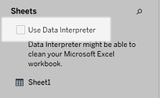

**Note:** When you clean your data with Data Interpreter, Data Interpreter cleans all the data associated with a connection in the data source. Data Interpreter does not change the underlying data.

1. In the Data pane, click the **Review the results** link to review the results of the Data Interpreter.

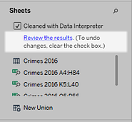

A copy of your data source opens in Excel on the **Key for the Data Interpreter** tab. Review the key to find out how to read the results.

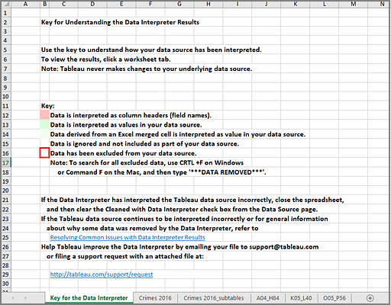

1. Click each tab to review how Data Interpreter interpreted the data source.

If Data Interpreter found additional tables, also called found tables or sub-tables, they are identified in the <sheet name>_subtables tab by outlining their cell ranges. A separate tab is also included for each sub-table, color coded to identify the header and data rows.

If Data Interpreter does not provide the expected results, clear the **Cleaned with Data Interpreter** check box to use the original data source.

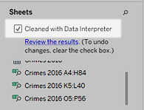

1. To replace the current table with any of the found tables, drag the current table off the canvas and then drag the found table that you want to use to the canvas.

If Data interpreter has misidentified the range of the found table, after you drag the found table to the canvas, click the drop-down arrow on that table, and then select **Edit Found Table** to adjust the corners of the found table (the top-left cell and bottom-right cell of the table).

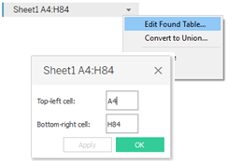

1. After you have the data that you want to work with, you can apply any additional cleaning operations to your data so that you can analyze it.

Data Interpreter Example

In this example we are connecting to an Excel spreadsheet with violent crime data by city and state for the year 2016. This spreadsheet includes multiple tables on one sheet and some extra formatting.

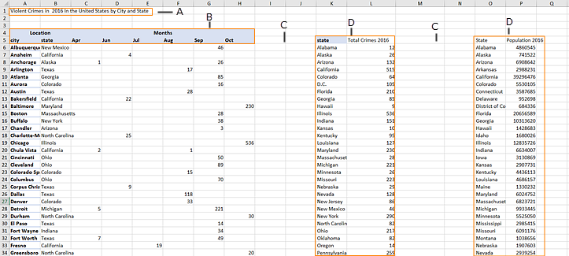

1. Title
2. Merged header cells
3. Extra white space
4. Sub-tables

The extra formatting in this spreadsheet makes it difficult for Tableau to determine what the field headers and values are.

Instead, it reads the data vertically and assigns each column the default value F1, F2, F3 (Field 1, Field 2, Field 3) and so on. Blank cells are read as null values.

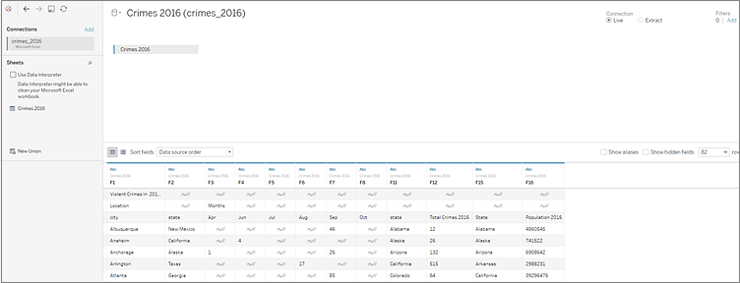

To see if Data Interpreter can help clean this data set, we select **Use Data Interpreter**.

Data Interpreter detected the proper headings for the fields, removed the extra formatting and found several sub-tables. The sub-tables are listed in the **Sheets** section in the Data pane and are named using the original sheet name and the cell ranges for each sub-table.

In this example there are three sub-tables: **Crimes 2016 A4:H84**, **Crimes 2016 K5:L40**, and **Crimes 2016 O5:P56**.

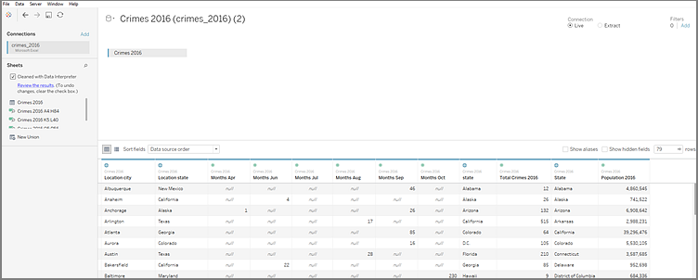

To examine the results of the Data Interpreter more closely, we click the **Review the results** link in the Data pane to view an annotated copy of the spreadsheet.

Here we see a copy of the original data, color coded to identify which data was identified as header data and which data was identified as field values.

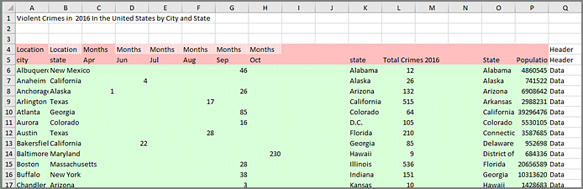

The next tab shows us the sub-tables that Data Interpreter found, outlined by the cell ranges.

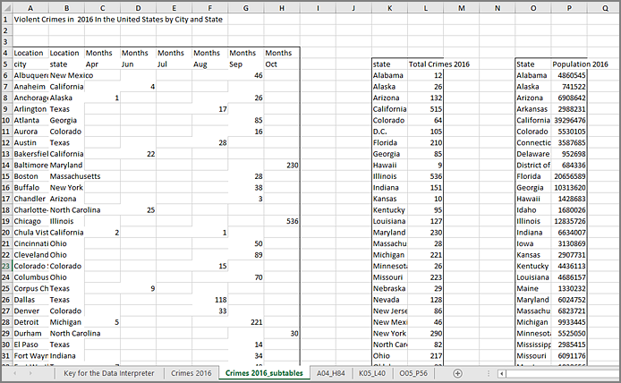

In this example the first sub-table, **Crimes 2016 A4:H84**, has the main data that we want to work with. To use this table as our data table, we can simply drag the original table off the canvas and then drag the new table to the canvas.

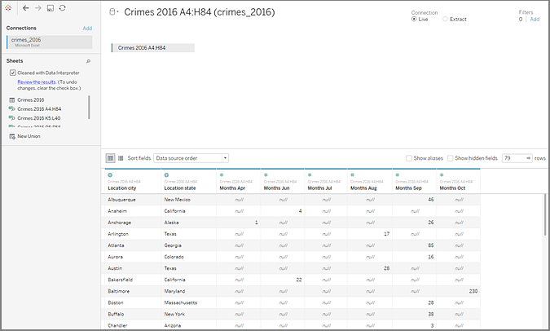

Once we have the data that we want to work with in the canvas, we can do some additional clean up on the data. For example we can:

* Change the field names so that they represent city, state, and month names.
* Pivot the months fields.
* Drag in the third sub-table **Crimes 2016 o5:P56** and join it to our first sub-table on the **State** field to include state populations for our analysis.
* Hide any duplicate fields that were added as a result of the join.

The results might look something like this:

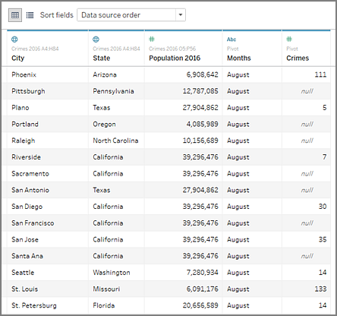

Now we are ready to start analyzing our data in Tableau.

When Data Interpreter is not available

The Data Interpreter option might not be available for the following reasons:

* **The data source is already in a format that Tableau can interpret:** If Tableau Desktop doesn't need extra help from Data Interpreter to handle unique formatting or extraneous information, the Data Interpreter option is not available.
* **Many rows or many columns:** The Data Interpreter option is not be available when your data has the following attributes:
  + Data contains more than 2000 columns.
  + Data contains more than 3000 rows and more than 150 columns.
* **The data source is not supported:** Data Interpreter is only available for Microsoft Excel, Text (.csv) files, PDF files and Google Sheets. For Excel, your data must be in the .xls or .xlsx format.